***Paint the picture.Use red, yellow, brown colours.***

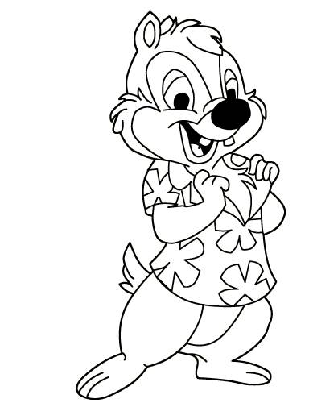

***Paint the picture***

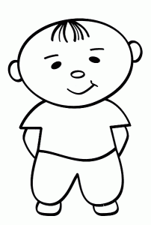

blue

blue

yellow

green

***Paint the picture. The horse is black and white.***

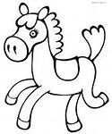

***This is the hen. Paint the picture. Use your imagination.***

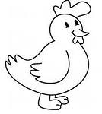

***Paint the picture***

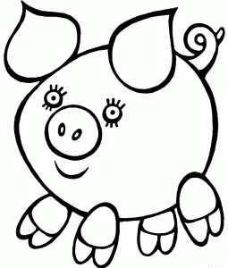

pink

brown

***Paint the picture. Use your imagination. The car is red.***

